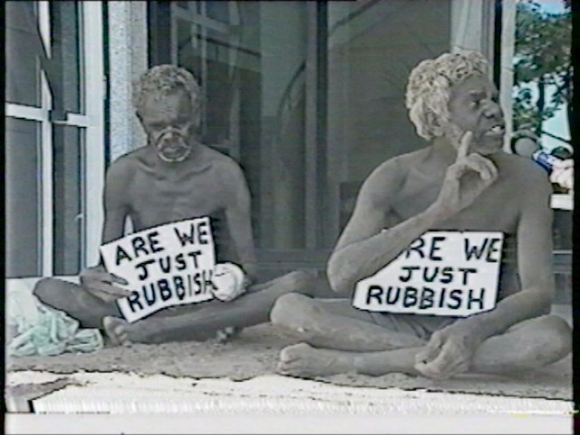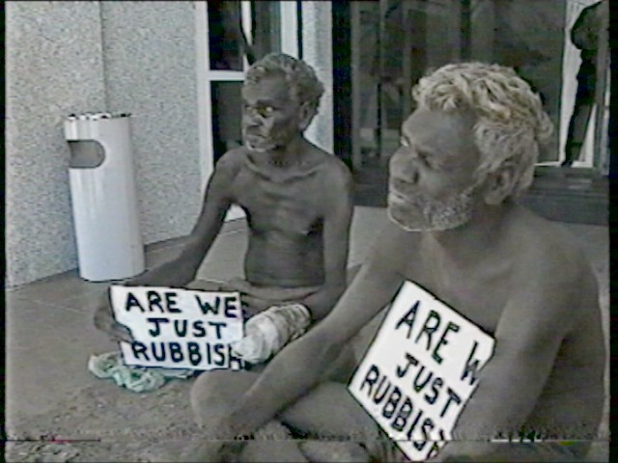
A month later, two men from Fish Camp threw bags of dust onto the steps of Parliament House.
They told the television reporters, ‘We live in the dust with no tap.’

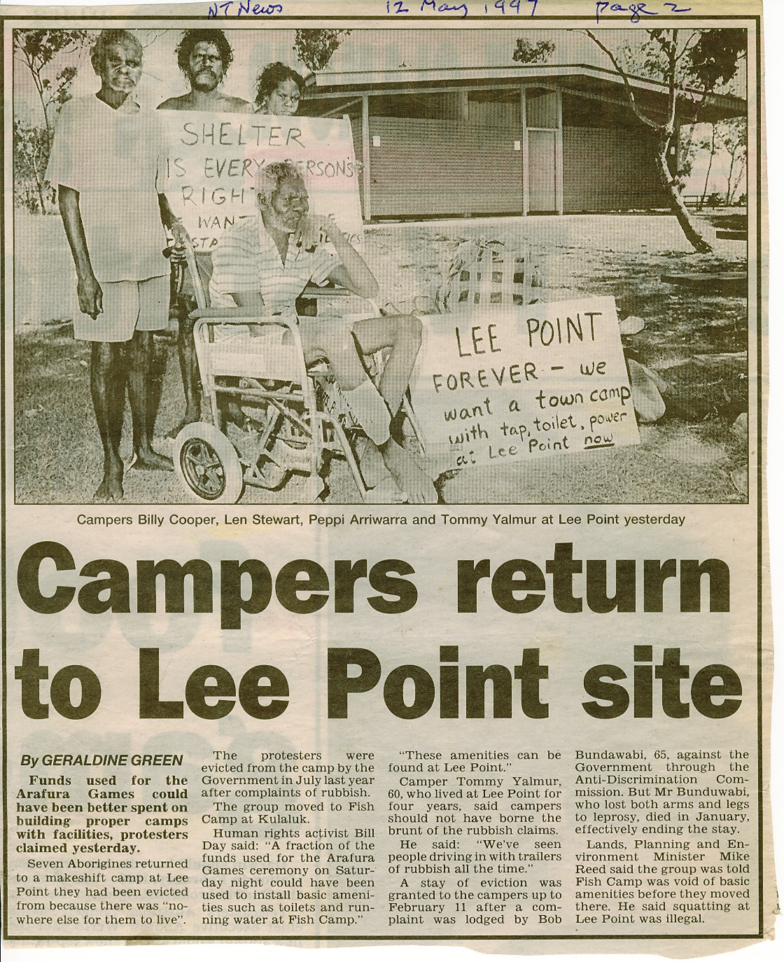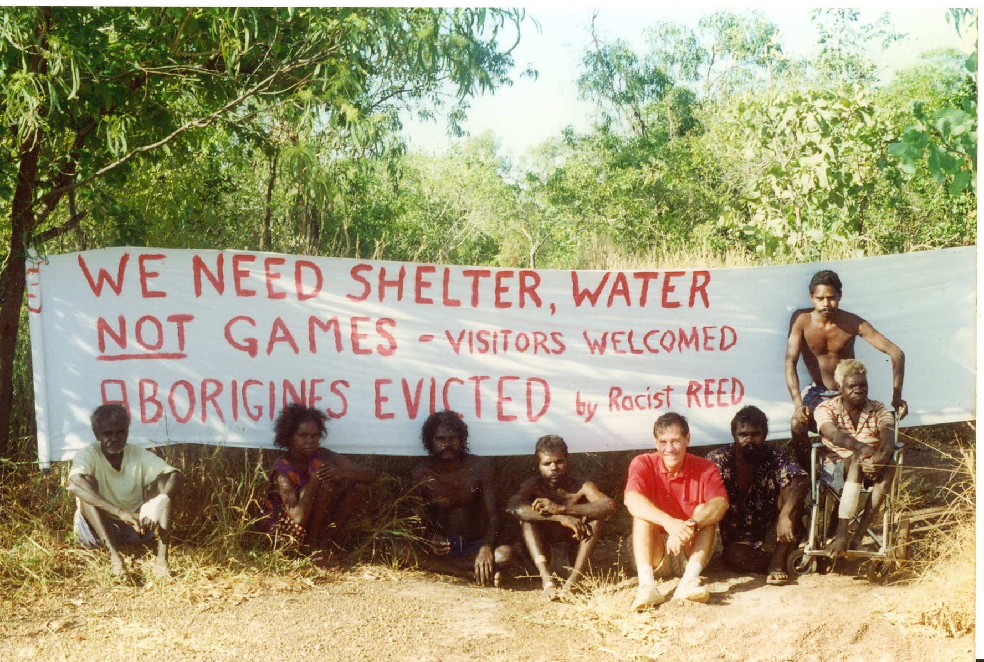
In memory of Gojok, more campers returned to Lee Point a week before the Arafura Sports Games. After 17 days, early one morning the NT Government sent a convoy of police vehicles to arrest the protesters on trespassing charges.

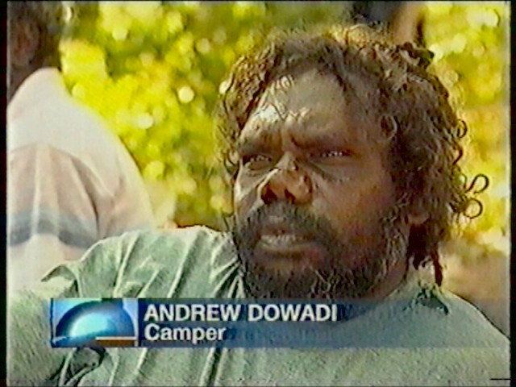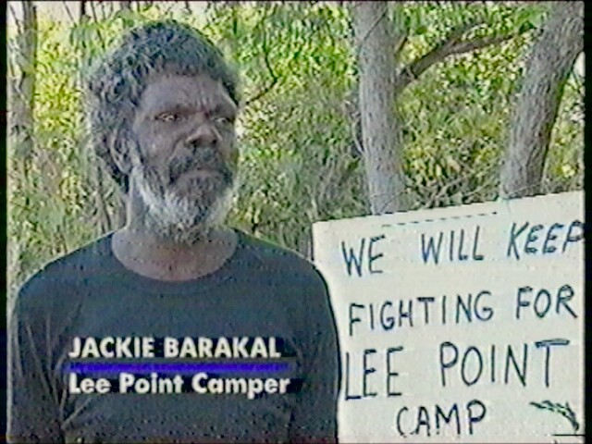

After the raid, some of Gojok’s family were interviewed by the media at Lee Point.

